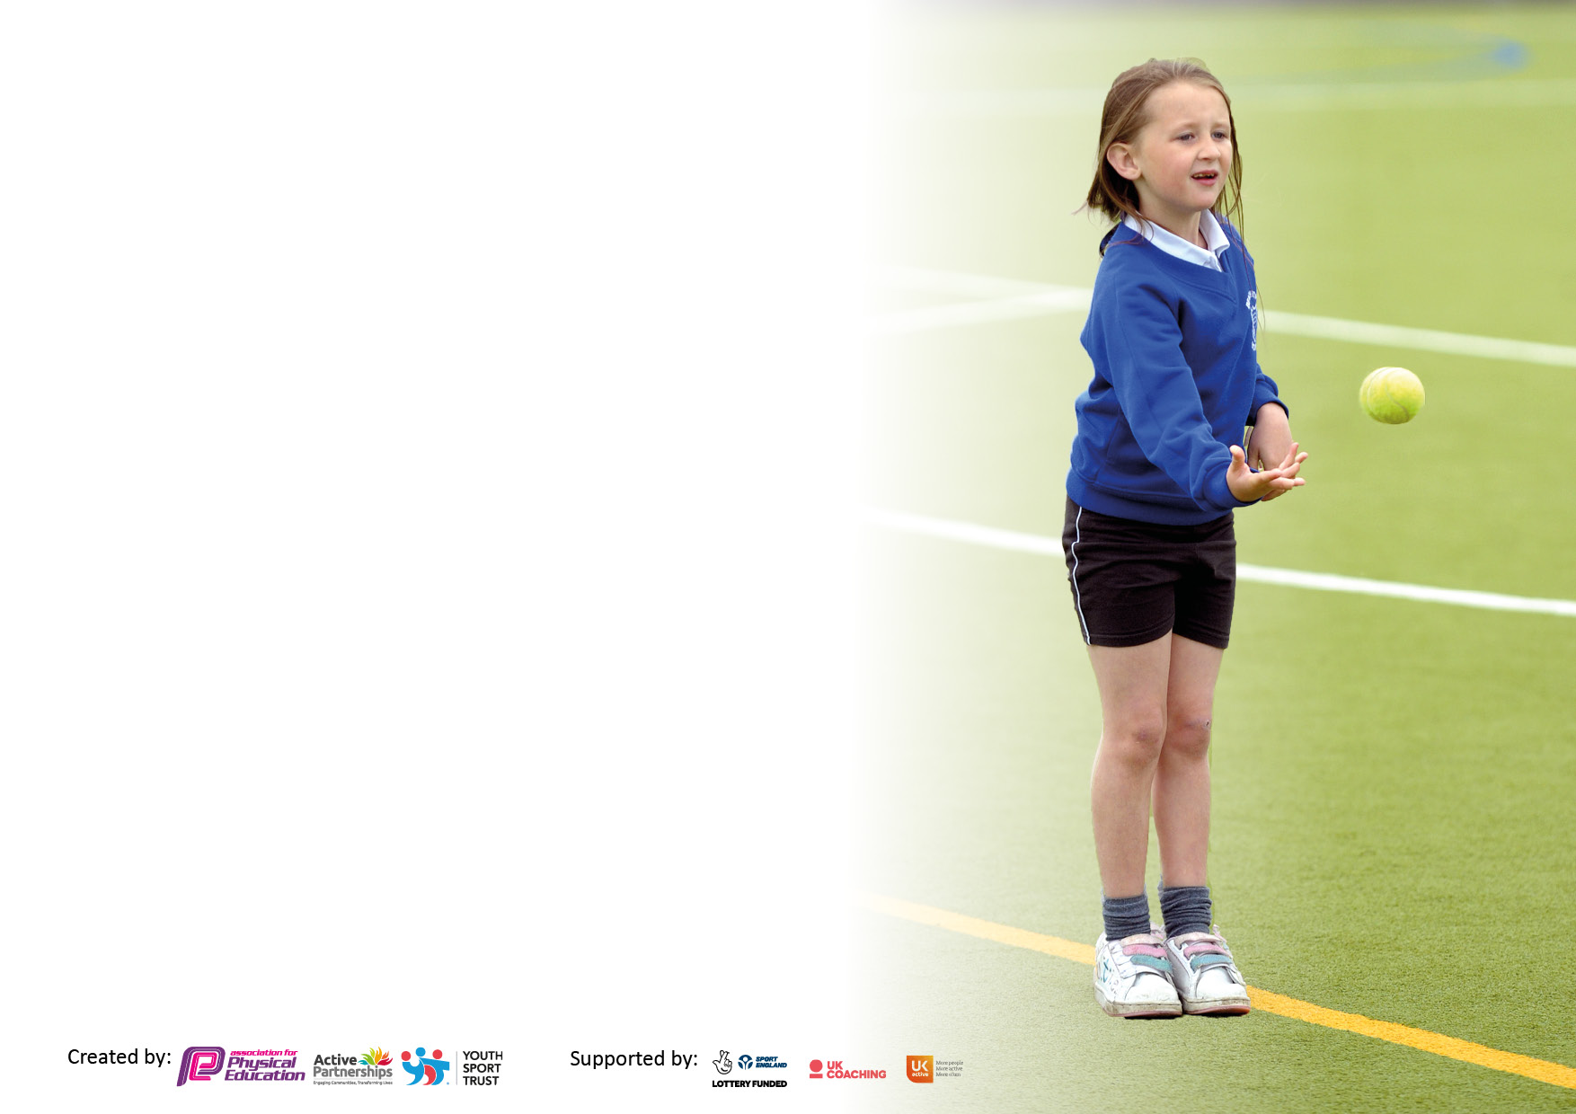

It is important that your grant is used effectively and based on school need. The Education Inspection Framework makes clear there will be a focus on **‘whether leaders and those responsible for governors all understand their respective roles and perform these in a way that enhances the effectiveness of the school’**.

Under the Quality of Education Ofsted inspectors consider:

**Intent** - Curriculum design, coverage and appropriateness

**Implementation** - Curriculum delivery, Teaching (pedagogy) and Assessment

**Impact** - Attainment and progress

To assist schools with common transferable language this template has been developed to utilise the same three headings which should make your plans easily transferable between working documents.

Schools must use the funding to make **additional and sustainable** improvements to the quality of Physical Education, School Sport and Physical Activity (PESSPA) they offer. This means that you should use the Primary PE and sport premium to:

* Develop or add to the PESSPA activities that your school already offer
* Build capacity and capability within the school to ensure that improvements made now will benefit pupils joining the school in future years
* The Primary PE and sport premium should not be used to fund capital spend projects; the school’s budget should fund these.

Pleasevisitgov.ukfortherevisedDfEguidanceincludingthe5keyindicatorsacrosswhichschoolsshoulddemonstrate animprovement.Thisdocumentwillhelpyoutoreviewyourprovisionandtoreportyourspend.DfEencouragesschools to use this template as an effective way of meeting the reporting requirements of the Primary PE and Sport Premium.

We recommend you start by reflecting on the impact of current provision and reviewing the previous spend.

Schools are required to publish details of how they spend this funding, including any under-spend from 2021/2022, as well as on the impact it has on pupils’ PE and sport participation and attainment. **All funding must be spent by 31st July 2023.**

We recommend regularly updating the table and publishing it on your website throughout the year. This evidences your ongoing self-evaluation of how you are using the funding to secure maximum, sustainable impact. Final copy must be posted on your website by the end of the academic year and no later than the 31st July 2023. To see an example of how to complete the table please click HERE.

**Details with regard to funding**

Please complete the table below.

|  |  |
| --- | --- |
| Total amount carried over from 2021/22 | £0 |
| Total amount allocated for 2021/22 | £0 |
| How much (if any) do you intend to carry over from this total fund into 2022/23? | £0 |
| Total amount allocated for 2022/23 | £16000 |
| Total amount of funding for 2023/24. To be spent and reported on by 31st July 2024. | £ 16000 |

**Swimming Data**

Please report on your Swimming Data below.

|  |  |
| --- | --- |
| Meeting national curriculum requirements for swimming and water safety.  N.B. Complete this section to your best ability. For example you might have practised safe self-rescue techniques on dry land which you can then transfer to the pool when school swimming restarts.  **Due to exceptional circumstances priority should be given to ensuring that pupils can perform safe self rescue even if they do not fully meet the first two requirements of the NC programme of study** |  |
| What percentage of your current Year 6 cohort swim competently, confidently and proficiently over a distance of at least 25 metres?  **N.B.** Even though your pupils may swim in another year please report on their attainment on leaving primary school at the end of the summer term 2022.  Please see note above | 75% |
| What percentage of your current Year 6 cohort use a range of strokes effectively [for example, front crawl, backstroke and breaststroke]?  Please see note above | 75% |
| **What percentage of your current Year 6 cohort perform safe self-rescue in different water-based situations?** | 75% |
| Schools can choose to use the Primary PE and sport premium to provide additional provision for swimming but this must be for activity **over and above** the national curriculum requirements. Have you used it in this way? | No |

**Action Plan and Budget Tracking**

Capture your intended annual spend against the 5 key indicators. Clarify the success criteria and evidence of impact that you intend to measure to evaluate for pupils today and for the future.

|  |  |  |  |  |
| --- | --- | --- | --- | --- |
| **Academic Year:** 2023/24 | **Total fund allocated:** | **Date Updated:** | |  |
| **Key indicator 1:** The engagement of all pupils in regular physical activity – Chief Medical Officers guidelines recommend that primary school pupils undertake at least 30 minutes of physical activity a day in school | | | | Percentage of total allocation: |
| 20% |
| **Intent** | **Implementation** | | **Impact** |  |
| Your school focus should be clear what you want the pupils to know and be able to do and about  what they need to learn and to  consolidate through practice: | Make sure your actions to achieve are linked to your intentions: | Funding allocated: | Evidence of impact: what do pupils now know and what can they now do? What has changed?: | Sustainability and suggested next steps: |
| All pupils to receive 2 hours taught PE a week. Pupils to access high quality PE.  Swimming lessons to promote physical activity heathy lifestyles, independence and life skills.  Audit and ordering of P.E. equipment in relation to subjects taught to enhance a high quality of PE.  Offer a range of afterschool clubs to each year group to reflect a range of interests.  Identify the less active children across school.  Continue the daily mile in every class.  Increase pupil’s participation in an active playtime of at least 15 minutes within their break and lunch time. | PE lead to ensure that each class has 2 lessons timetabled. Coordinator to monitor planning/assessment.  Year 4 timetabled into the swimming baths for high quality swimming lessons. Coordinator to monitor effectiveness and survey children at the start and end of the year.  Coordinator to audit PE equipment in line with curriculum for September 23.  Coordinator to questionnaire staff to find out interests and spread the clubs out throughout the year.  Coordinator to survey children at the start of September 23 to see what clubs they would like to attend.  Continue to offer after school clubs ran by outside agencies.  Staff to survey children in their class to find out who attends clubs outside of school.  Coordinator to be aware of the children who do not and offer an active club for these children on a lunch time – targeted by the playground leaders.  Coordinator to create a timetable to ensure all classes are participating in the daily mile. Coordinator to monitor throughout the year.  KS2 to rota the football pitch during break and lunch times – different class each week.  Coordinator to train Year 5 playground leaders to lead different games each week.  Coordinator to organize equipment to ensure there is a range of activities for children to access during both break and lunch time. |  |  |  |
| **Key indicator 2:** The profile of PESSPA being raised across the school as a tool for whole school improvement | | | | Percentage of total allocation: |
| 20% |
| **Intent** | **Implementation** | | **Impact** |  |
| Your school focus should be clear what you want the pupils to know and be able to do and about  what they need to learn and to  consolidate through practice: | Make sure your actions to achieve are linked to your intentions: | Funding allocated: | Evidence of impact: what do pupils now know and what can they now do? What has changed?: | Sustainability and suggested next steps: |
| Year 5 playground leaders to develop coaching skills by leading different activities on the yard at break and lunch time.  Raise the profile of sport in school by ensuring curriculum provision includes sport and PE activities that are varied, age-appropriate and suitably ambitious.  Give all children the opportunity to participle in events, competitions and festivals throughout the year (including those with SEND).  Continue to enforce a high profile of PE/School sport across school. | Year 5 leaders to attend GSSP training.  Coordinator to review leaders throughout the year and make changes where needed.  GSSP credits to go towards coordinator and staff coaching to ensure a high-quality PE curriculum.  NUFC and Grassroots to provide coaching to staff during curriculum led time.  Coordinator to use the GSSP events calendar and ensure all classes are attended at least 1 event and ensure SEND children across the school attend relevant events.  Staff and coordinator to monitor PE uniform and ensure all children are wearing the correct uniform.  Head teacher to remind parents on newsletters of expectations when needed.  Staff to wear their PE uniform to set an example. |  |  |  |

|  |  |  |  |  |
| --- | --- | --- | --- | --- |
| **Key indicator 3:** Increased confidence, knowledge and skills of all staff in teaching PE and sport | | | | Percentage of total allocation: |
| 20% |
| **Intent** | **Implementation** | | **Impact** |  |
| Your school focus should be clear | Make sure your actions to | Funding | Evidence of impact: what do | Sustainability and suggested |
| what you want the pupils to know | achieve are linked to your | allocated: | pupils now know and what | next steps: |
| and be able to do and about | intentions: |  | can they now do? What has |  |
| what they need to learn and to |  |  | changed?: |  |
| consolidate through practice: |  |  |  |  |
| Develop the skills and  Knowledge of the PE  Curriculum lead.  Upskill teachers in  delivering a quality P.E.  curriculum through staff  working alongside specialist  P.E. coaches.  Getset4pe scheme of work | Curriculum Lead to attend the GSSP PE CPD courses and to feedback to other staff to develop staff knowledge.  Staff to received coaching from NUFC, Grassroots and GSSP throughout the year.  Staff to team teach alongside external coaches to develop skills and knowledge.  Staff to use GetSet4PE to help plan and deliver PE lessons. | £ |  |  |
| **Key indicator 4:** Broader experience of a range of sports and activities offered to all pupils | | | | Percentage of total allocation: |
| 20% |
| **Intent** | **Implementation** | | **Impact** |  |
| Your school focus should be clear | Make sure your actions to | Funding | Evidence of impact: what do | Sustainability and suggested |
| what you want the pupils to know | achieve are linked to your | allocated: | pupils now know and what | next steps: |
| and be able to do and about | intentions: |  | can they now do? What has |  |
| what they need to learn and to |  |  | changed?: |  |
| consolidate through practice: |  |  |  |  |
| Children to experience a range of subjects throughout the year.  Children provided with opportunities to compete with themselves and other schools.  Children to be offered a range of after school clubs. | Coordinator to use the GetSet4PE programme to help plan a varied curriculum for all year groups.  Staff/Coaches to run end of unit intra competitions in all subjects for all children.  Coordinator to monitor intra and inter competitions to ensure all year groups have a varied amount.  Year 3 children to perform at the Dance Festival.  Coordinator to ensure involved with Thorp activities/events is active throughout year groups.  Coordinator to plan a range of after school clubs available to all children throughout the year.  Coordinator/Head teacher to organise with external companies clubs that they can offer Blaydon West:  Kensho Karate  NUFC | £ |  |  |

|  |  |  |  |  |
| --- | --- | --- | --- | --- |
| **Key indicator 5:** Increased participation in competitive sport | | | | Percentage of total allocation: |
| 20% |
| **Intent** | **Implementation** | | **Impact** |  |
| Your school focus should be clear | Make sure your actions to | Funding | Evidence of impact: what do | Sustainability and suggested |
| what you want the pupils to know | achieve are linked to your | allocated: | pupils now know and what | next steps: |
| and be able to do and about | intentions: |  | can they now do? What has |  |
| what they need to learn and to |  |  | changed?: |  |
| consolidate through practice: |  |  |  |  |
| Increase children’s participation in competitive sport, including an element of personal challenge.  Encourage all children to set personal goals and help each child to achieve them. | Staff to deliver an end of unit competition within their year group for each subject taught.  Head teacher to renew the GSSP package.  Coordinator to plan competitions for children to attend throughout the year linked to the GSSP calendar.  Children to participate in competitive clubs which will create a team to attend external competitions:  Football  Netball  Coordinator to monitor the attendance of events/tournaments:  -Enter cluster tournaments.  -Each class will attend at least one tournament/festival  - Involvement in competitions at Thorp  Coordinator to organise whole school sports day.  Staff to deliver personal best activities in PE and provide competitions to achieve their personal best.  Playground leaders to challenge children in break and lunch times to achieve their own personal PE targets. | £ |  |  |